Chapter 4 – Page 171 - #7

# Problem Statement

A software company sells a package that retails for $99. Quantity discounts are given according to the following table:

|  |  |
| --- | --- |
| **Quantity** | **Discount** |
| 10-19 | 20% |
| 20-49 | 30% |
| 50-99 | 40% |
| 100 or more | 50% |

Design a program to:

# Algorithm

1. Ask the user to enter the number of packages purchased
2. Display:
   1. Amount of the discount
   2. Total amount of purchase after the discount

# IPO Diagrams

Main module

|  |  |  |
| --- | --- | --- |
| Input | Processing | Output |
| quantity | If (quantity < 10): discount = 0  If (quantity >= 10 and < 20): discount= 0.02  If (quantity >= 20 and < 50): discount = 0.03  If (quantity >= 50 and < 100): discount = 0.04  If (quantity >= 100): discount = 0.05  Call receipt(quantity, discount) |  |

Receipt module

|  |  |  |
| --- | --- | --- |
| Input | Processing | Output |
| quantity  discount | Calculate total = quantity * $99  Calculate discountTotal = total * discount  Calculate total = total - discountTotal | Display discountTotal  Display total |

# Hierarchy Charts

# Flowcharts

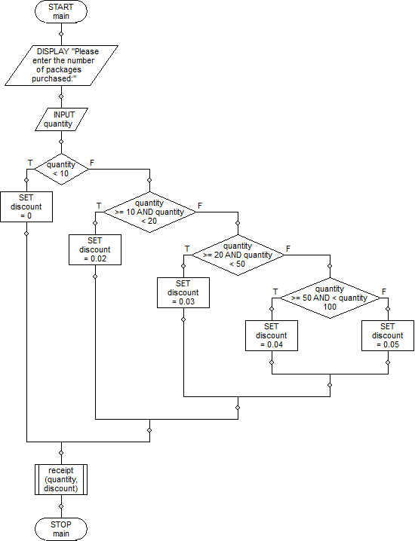

# Pseudocode

// Program: Chapter 4 - Page 171 - #7 v1 MDoctor

// Author: Mark Doctor

// Course: iTechPM

void main ()

{

DISPLAY "Please enter the number of packages purchased:";

INPUT quantity;

if (quantity < 10)

{

SET discount = 0;

}

else

if (quantity >= 10 AND quantity < 20)

{

SET discount = 0.02;

}

else

if (quantity >= 20 AND quantity < 50)

{

SET discount = 0.03;

}

else

if (quantity >= 50 AND < quantity 100)

{

SET discount = 0.04;

}

else

SET discount = 0.05;

receipt (quantity, discount);

}

void receipt (quantity, discount)

{

SET total = quantity * $99;

SET discountTotal = total * discount;

SET total = total - discountTotal;

DISPLAY "Discount total: $", discountTotal;

DISPLAY "Total: $", total;

}

# Java Source Code

1 //Mark Doctor, 10/2/16, iTechPM Section 4: Assignment 4b   
 2 //Purpose: Learn decision structures   
 3 //Filename: softwareSales.java  
 4 //Documentation: Chapter 4 - P171 - #7 MDoctor.docx  
 5   
 6 import java.util.*;  
 7 import java.text.*;  
 8   
 9 public class softwareSales  
10 {  
11 public static Scanner kb = new Scanner(System.in);  
12   
13 public static void main(String[] args)  
14 {  
15 //variable declaration  
16 int quantity;  
17 double discount;  
18   
19 //get quantity from user  
20 System.out.println("Please enter the number of packages purchased: ");  
21 quantity = kb.nextInt();  
22   
23 //get discount  
24 if(quantity < 10)  
25 discount = 0;   
26 else if (quantity < 20)  
27 discount = 0.02;  
28 else if (quantity < 50)  
29 discount = 0.03;  
30 else if (quantity < 100)  
31 discount = 0.04;  
32 else  
33 discount = 0.05;  
34   
35 //call receipt with the quantity and discount  
36 receipt(quantity, discount);  
37   
38 }//end of main  
39   
40 public static void receipt(int quantity, double discount)  
41 {  
42 //variable declaration  
43 double total, discountTotal;  
44 DecimalFormat df = new DecimalFormat("#.00");  
45 //Calculate total and discountTotal  
46 total = quantity * 99;  
47 discountTotal = total * discount;  
48 total = total - discountTotal;  
49   
50 //Display total and discountTotal  
51 System.out.println("Discount total: $" + df.format(discountTotal));  
52 System.out.println("total: $" + df.format(total));  
53   
54 }//end of receipt  
55   
56 }//end of class  
57   
58 /*  
59 ----jGRASP exec: java softwareSales  
60 Please enter the number of packages purchased:   
61 50  
62 Discount total: $198.00  
63 total: $4752.00  
64   
65 ----jGRASP: operation complete.  
66 */